SIMATS ENGINEERING
ASSESSMENT TOOL 3
COURSE CODE: MLA 02 COURSE NAME: Fundamentals Of Machine Learning
COURSE OUTCOME COVERED
CO5: Create graphical models to analyze and infer patterns in complex probabilistic systems for structured decision-making.(BL5)
Assessment Tool Weightage: 10%
QUESTIONS: 10 Total Marks:50 Annexure A
Mock Interview
Code of Conduct:
I ___PradeepKumar(192425016)_________________ (Name / Reg No) certify that this submission is my original work and that I have adhered to the guidelines specified for this assessment.
I understand that any violation of academic integrity rules will result in disciplinary action. Signature of the student:
Annexure A

Mock Interview
Q1. “Suppose you are working on an industrial monitoring system. How would you use Bayesian Networks to predict machine failures?” (5 Marks – 8 Mins)
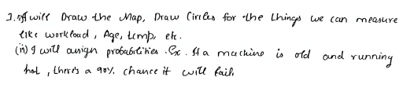
Q4. “During a technical interview, how would you explain the use of Conditional Random Fields for sequence labeling tasks such as part-of-speech tagging?” (5 Marks – 8 Mins)
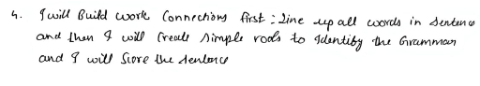
Q6. “In a healthcare diagnosis problem, how would you compare directed graphical models and undirected graphical models for representing symptom relationships?” (5 Marks – 8 Mins)
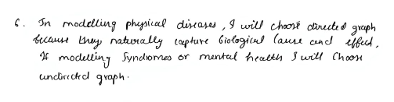

Q9. “In an NLP interview task, how would you explain why Conditional Random Fields often outperform Hidden Markov Models in named entity recognition?” (5 Marks – 8 Mins)
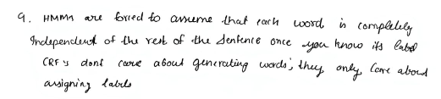

RUBRICS FOR CALCULATION
Criteria | Weight  age | Level 4  (Exemplary) | Level 3  (Proficient) | Level 2  (Developing  ) | Level 1  (Beginning)
Technical  Knowledge | 25 | Demonstrat  es strong  and  accurate  subject  knowledge  with in  depth  understandi  ng | Shows  good  knowledge  with minor  gaps | Basic  knowledge  with  noticeable  errors | Lacks  fundamental  technical  knowledge
Problem  Solving | 25 | Solves  problems  logically  and applies  concepts  effectively  in real  scenarios | Applies  concepts  with  moderate  accuracy | Limited  problem  solving  ability;  requires  guidance | Unable to  solve or  apply  concepts
Analytical  Thinking | 15 | Analyzes  questions  critically  and  provides  well  structured,  logical  answers | Provides  reasonable  analysis  with some  structure | Superficial  or partially  structured  responses | No  analytical  thinking  demonstrate  d
Communica  tion | 15 | Communica  tes clearly,  confidently,  and  professional  ly with  proper  terminology | Communica  tes well with  minor  hesitation | Communicat  ion lacks  clarity or  confidence | Unable to  communicat  e effectively
Confidence | 15 | Displays  high  confidence,  positive  attitude,  and  professional | Shows  good  confidence  with minor  issues | Low  confidence;  inconsistent  behavior | Lacks  confidence  and  professionali  sm

behavior
throughout
Response  to  Questions | 10 | Responds  accurately,  promptly,  and  elaborates  with  relevant  examples | Responds  correctly  but with  limited  depth | Partial  responses;  needs  prompting | Unable to  respond  appropriatel  y

